

Dhaka International University
Lab Report details:
Lab Report Topic : Write a code for Shortest Job First Algorithm using C/C++
Lab Report No : 02
Course Title : Operating System
Course Code : 0613-302

Submitted By: | Submitted To:
S M Nabil Ausaf  Roll: 01  Reg No : CS-D-91-23-124492 | Md. Nazmus Sakib,  Lecturer of CSE Department

Date of Submission:07.11.25

Lab No: 02
Lab Report Name
Implementation of Shortest Job First (SJF) CPU Scheduling Algorithm
Objectives
- To understand the concept of CPU scheduling and its importance in process management.
- To learn and implement the Shortest Job First (SJF) scheduling algorithm.
- To calculate Average Waiting Time and Average Turnaround Time.
- To compare the performance of SJF with other scheduling techniques (conceptually).
Background Study (with Example)
Definition:
Shortest Job First (SJF) is a non-preemptive CPU scheduling algorithm where the process with the smallest burst time is executed first. It minimizes the average waiting time for a set of processes.
Key Terms:
- Burst Time (BT): The time required by a process for execution.
- Waiting Time (WT): The total time a process spends waiting in the ready queue.
- Turnaround Time (TAT): The total time taken from process arrival to completion.
Formulas:
$$WT_{i}=TAT_{i}-BT_{i} \\ TAT_{i}=CompletionTime_{i}-ArrivalTime_{i}$$

Example:
Process | Burst Time (ms)
P1 | 6
P2 | 8
P3 | 7
P4 | 3

Execution Order: P4 → P1 → P3 → P2
Average Waiting Time = 7.75 ms
Average Turnaround Time = 15.75 ms

Code
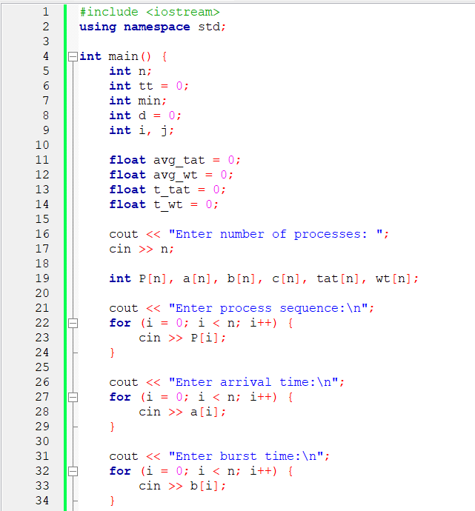
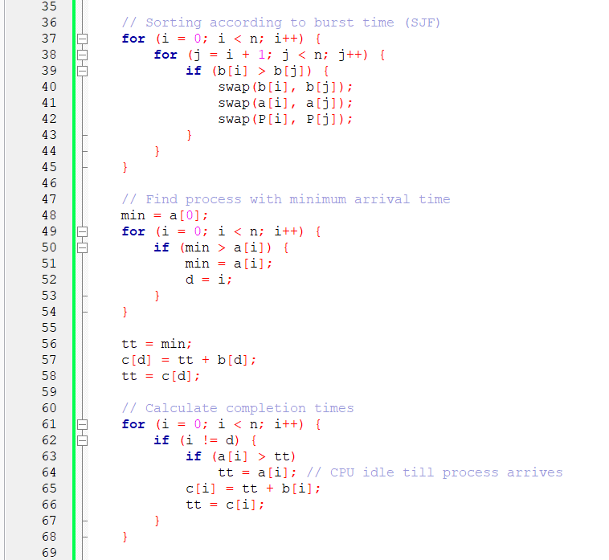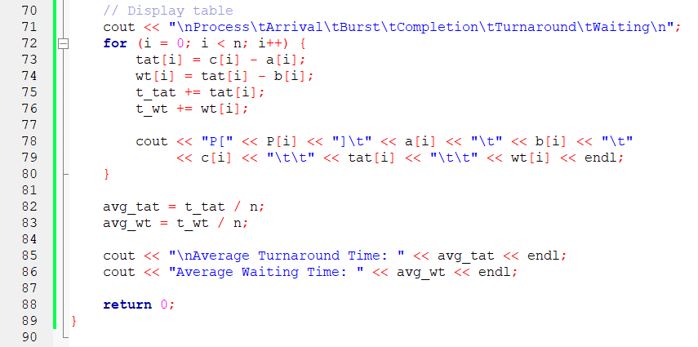
Input
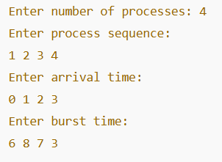

Output:

Process | Arrival Time | Burst Time | Completion Time | Turnaround Time (CT–AT) | Waiting Time (TAT–BT)
P4 | 3 | 3 | 6 | 3 | 0
P1 | 0 | 6 | 12 | 12 | 6
P3 | 2 | 7 | 19 | 17 | 10
P2 | 1 | 8 | 27 | 26 | 18

Discussion
In this experiment, we implemented the Shortest Job First (SJF) scheduling algorithm.
The results show that by executing the shortest process first, the average waiting time and average turnaround time are minimized compared to other algorithms like FCFS (First Come First Serve).

Advantages:
- Provides minimum average waiting time.
- Efficient for batch systems with known burst times.
Disadvantages:
- Not suitable for real-time systems.
- Requires prior knowledge of burst times.
- May cause starvation for longer processes.

Conclusion
The Shortest Job First (SJF) algorithm was successfully implemented and tested. It efficiently reduces average waiting and turnaround times by executing the shortest processes first. However, it requires knowing burst times in advance and may cause starvation for longer processes.

